**Measure of Central Tendency:** Mean, Median, Mode

Mean or Average: 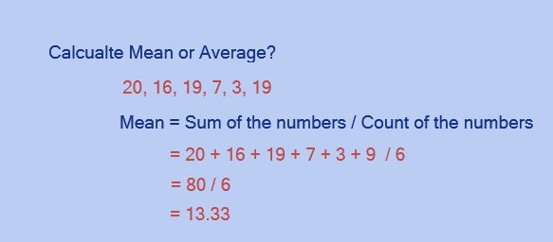

Median: The Median is the ***"middle"*** of a sorted list of numbers.

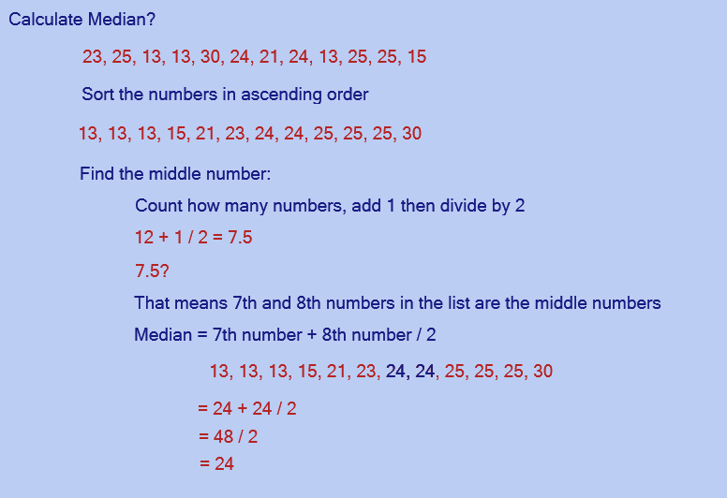

Mode: The number which appears most often in a set of numbers.

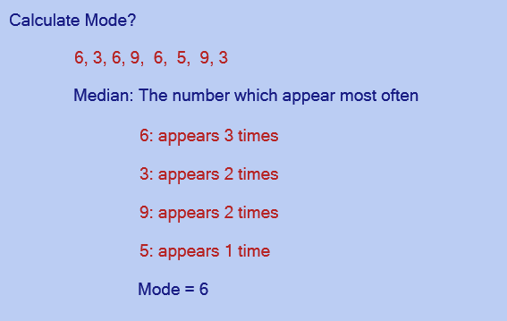

**Equations:**

Mean, Median and Standard Deviation

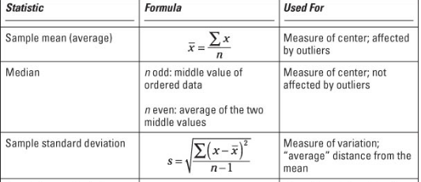

Standard Deviation:

Example: 14, 60, 70, 35, 45

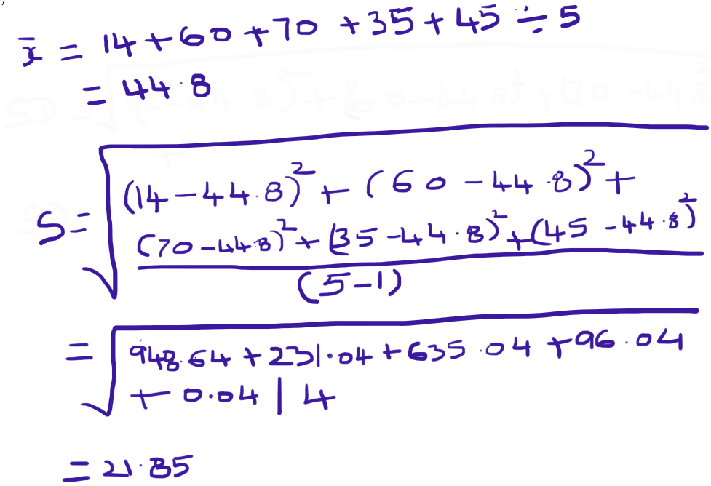

**Summary Statistics using Excel:**

Instead of calculating manually like above, we can do this in Excel. Here is a screen shot.

1. Open Excel
2. Enter the Data – 14 60 70 35 45
3. Click on ‘Data’ in the menu
4. Click on ‘Data Analysis’ in the menu (This option is all the way to the right)

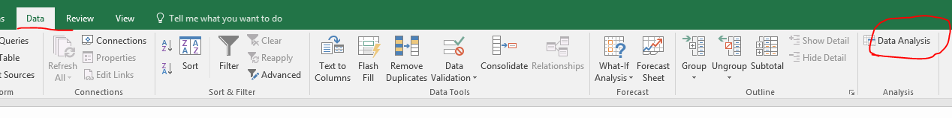

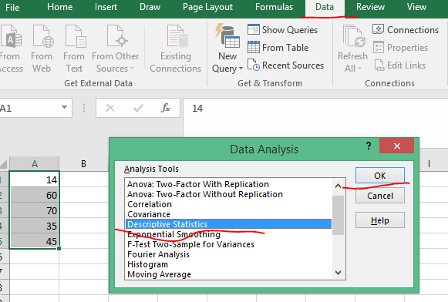

1. Click Ok
2. Select
   1. Input Range
   2. Output Range

Click Ok

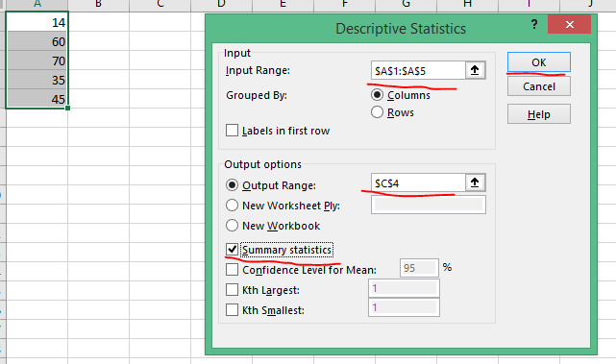

7.

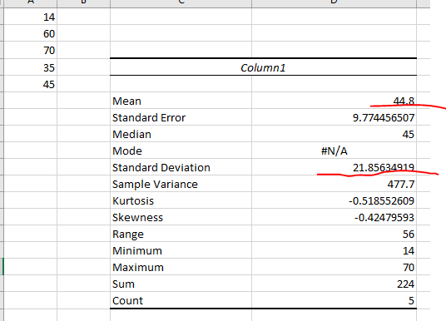

The Mean and Standard Deviation, we calculated early are matching.

**IMPORTANT**

Please try to use the Excel to display ‘Summary Statistics’ few times using different data sets, because we need this in the later lessons.